1. Mind Map
When students begin their preview studies, utilising the mind-mapping feature allows them to systematically categorise concepts and topics from the vast array of materials provided via the LMS, thereby creating a structure that enables a quick grasp of the overall content. International students can choose their own language for the mind map to enhance their understanding.
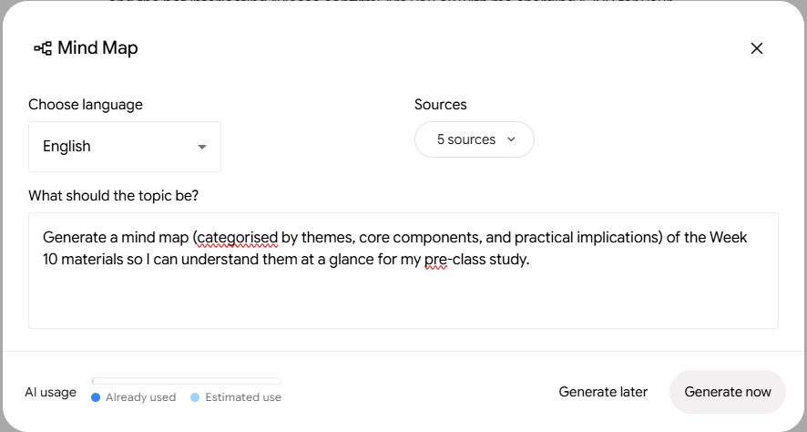
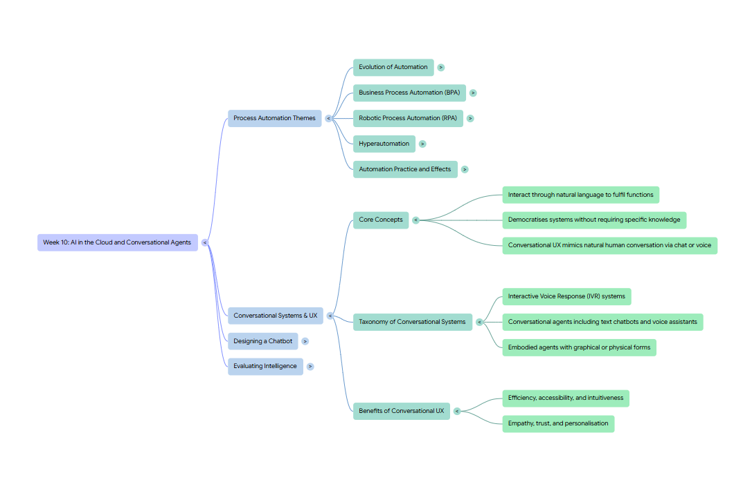

2. Slide Deck
The slide deck feature consolidates content scattered across various materials into a single slide, allowing students to study using just one resource without having to switch between multiple files. Each slide not only summarises and explains the concept but also provides relevant visuals or icons to aid understanding, enabling students to grasp the concepts more quickly.
Students can choose the slide format—prioritising either content or visuals—based on their preferences and set the slide length. International students have the option to create slides in their preferred language.
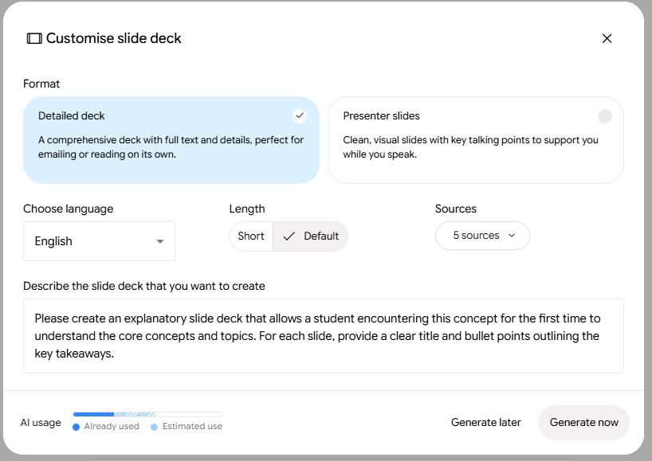
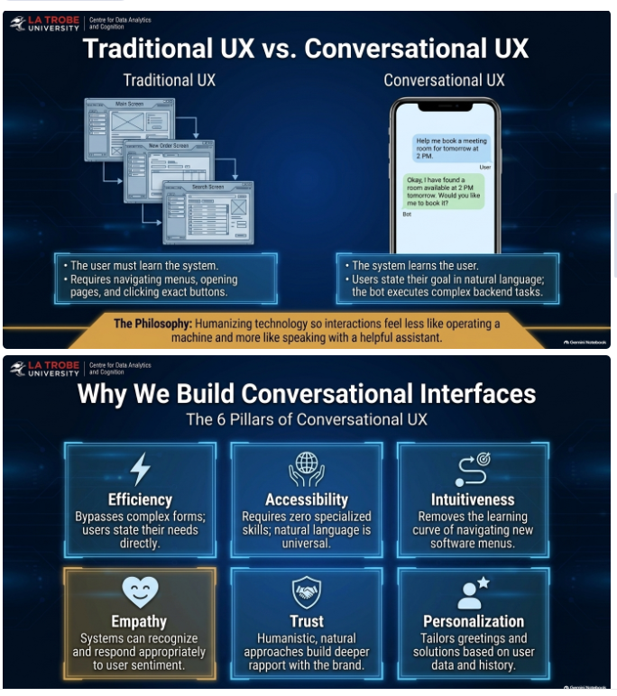
3. Infographic
Students can use infographic tools to visualise concepts, such as the chatbot design process, that are easier to understand through diagrams than through text alone.
Students can select the level of detail based on the depth of the concept they wish to visualize and set the language according to their preference.
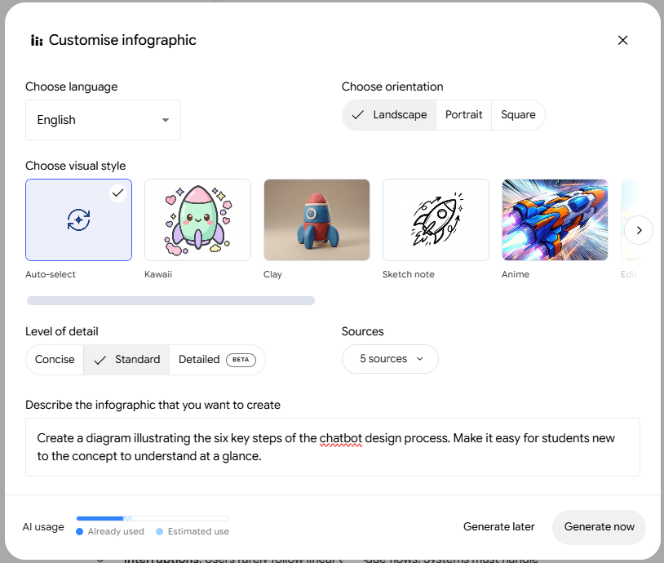
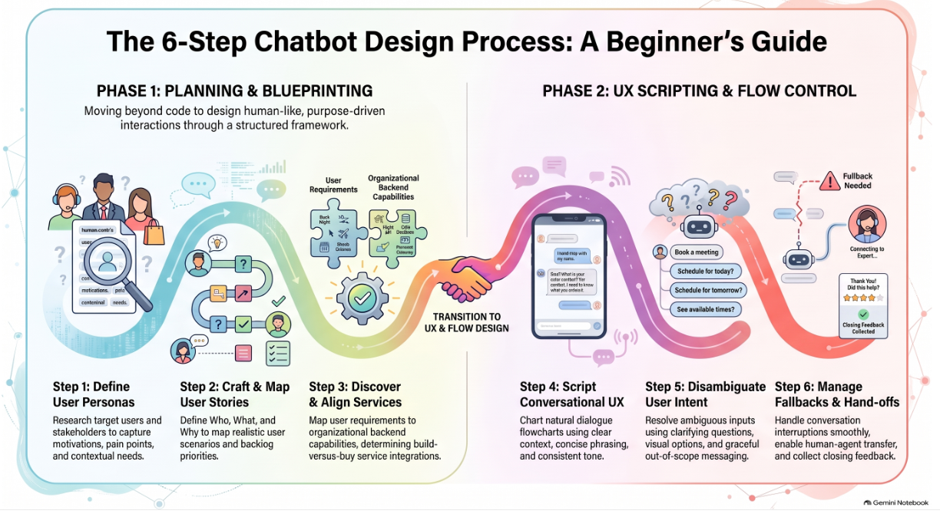

4. Video Overview
Students who struggle to grasp a particular concept can create a video explaining it to aid their understanding. They can choose the video length based on the depth of the concept and either select a topic they wish to explore further or enter one manually. Additionally, they can set the language to their preference.
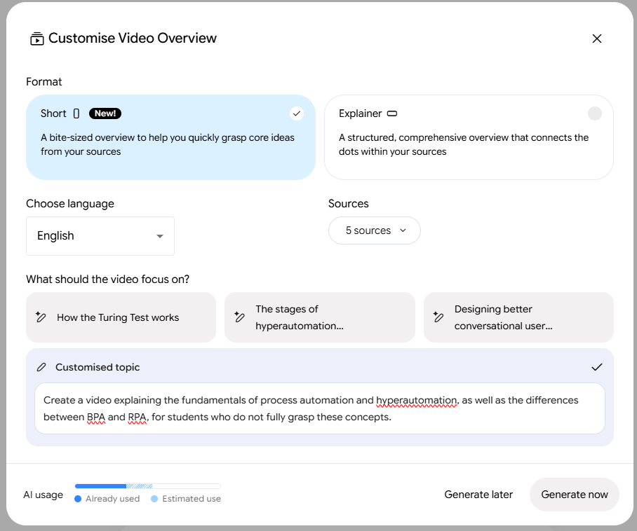
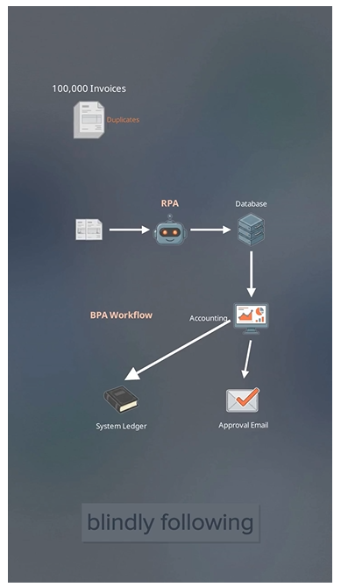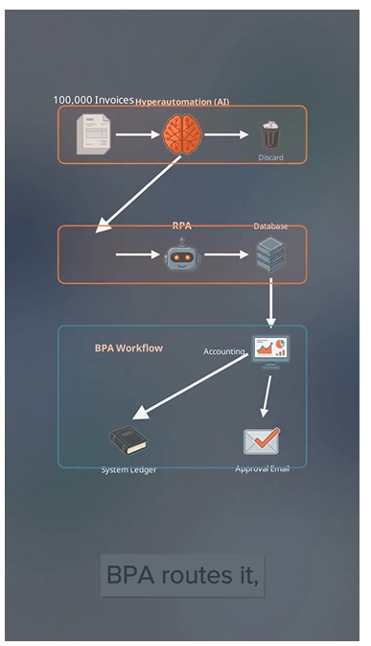

5. Flashcards
Students who have studied concepts and topics using the features mentioned above can use the flashcard function to memorise key concepts, theories, and more.
Students can select the number of cards, difficulty level, whether to include images, the topic, and the language.
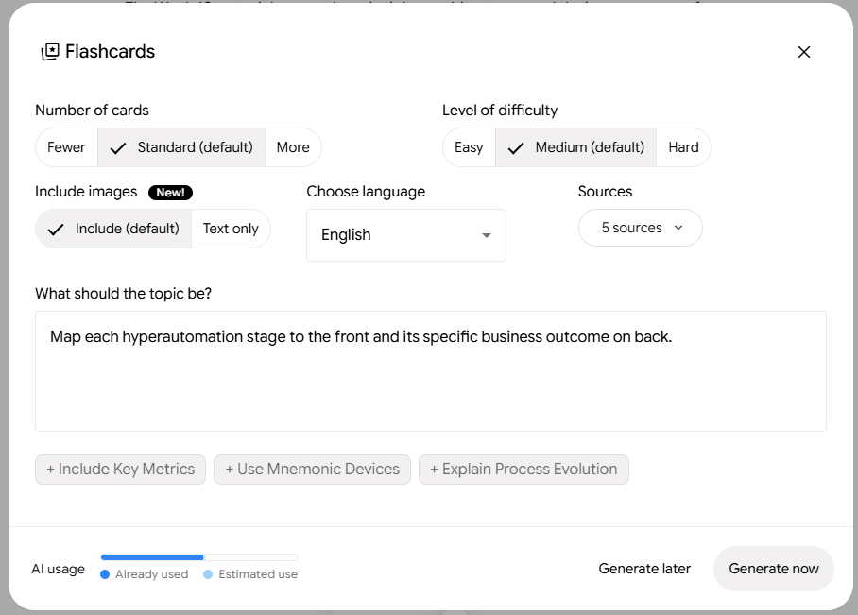
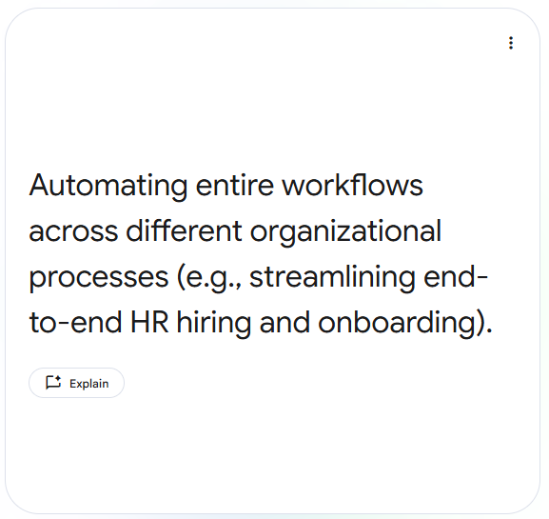

6. Quiz
After previewing the material, students can create quizzes covering key concepts and theories to assess their own level of understanding. Students can personally select the number of questions, the level of difficulty, and the language.
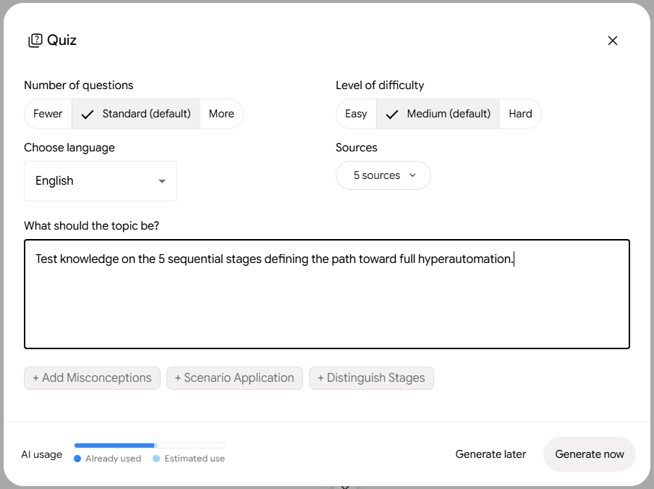
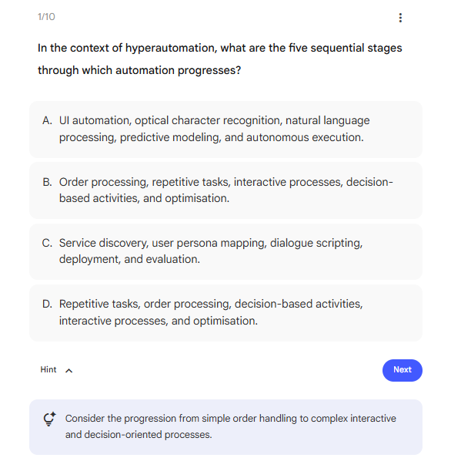
7. Audio Overview
While it is ideal for students to read all course materials and build their understanding using the aforementioned features, those who lack the time can instead listen to audio podcasts covering the material on their way to university, allowing them to preview the content without significant effort or time investment. Students can choose the podcast format, length, and topic, and select their preferred language. While listening to a podcast, students can engage interactively, by using the "join" feature to ask questions or requesting that the host provide further explanation.
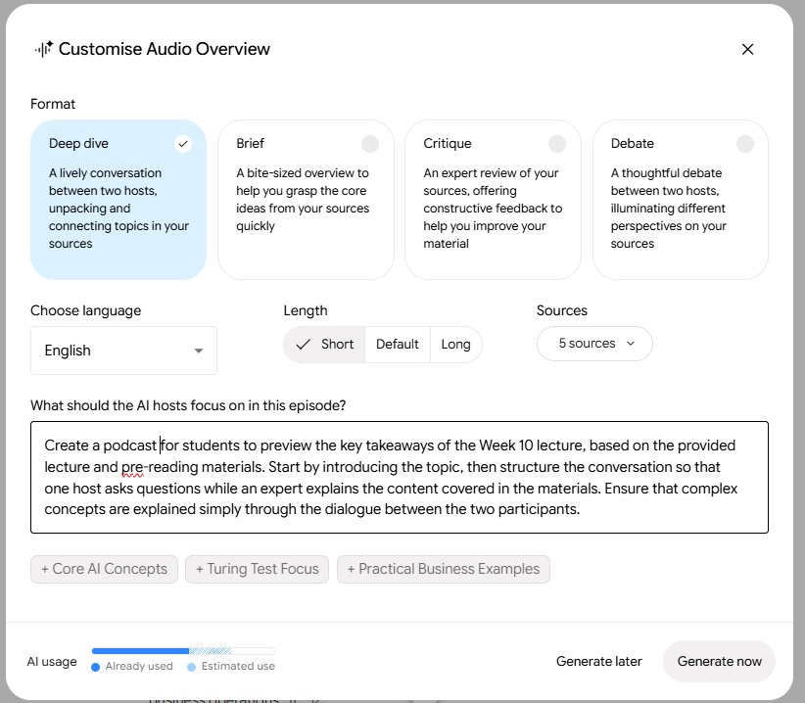

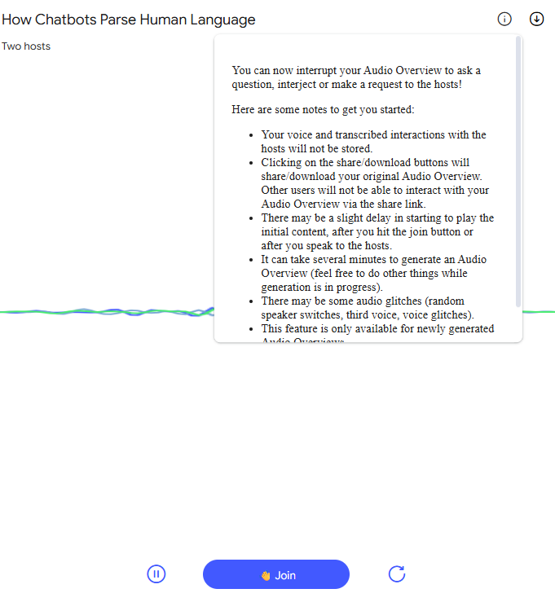
8. Report
Students can create notebooks for class preparation. By organising each page by topic—with key concepts, vocabulary, and a simple quiz at the top, space for lecture notes in the center, questions or areas for further research at the bottom—they can use these files during class.
A practical limitation was identified: AI fails to fully recognise spatial layouts, causing text to become jumbled or output as simple, continuous blocks; consequently, post-processing—such as re-editing in Word or Notion—is essential before instructors or students can print the material for use as handwritten handouts.
